- Created a new investor account, entered OTP (first OTP that I was supposed to receive in my email), then it redirected me to set password. It looks like I am in reset password page. (Still Same)
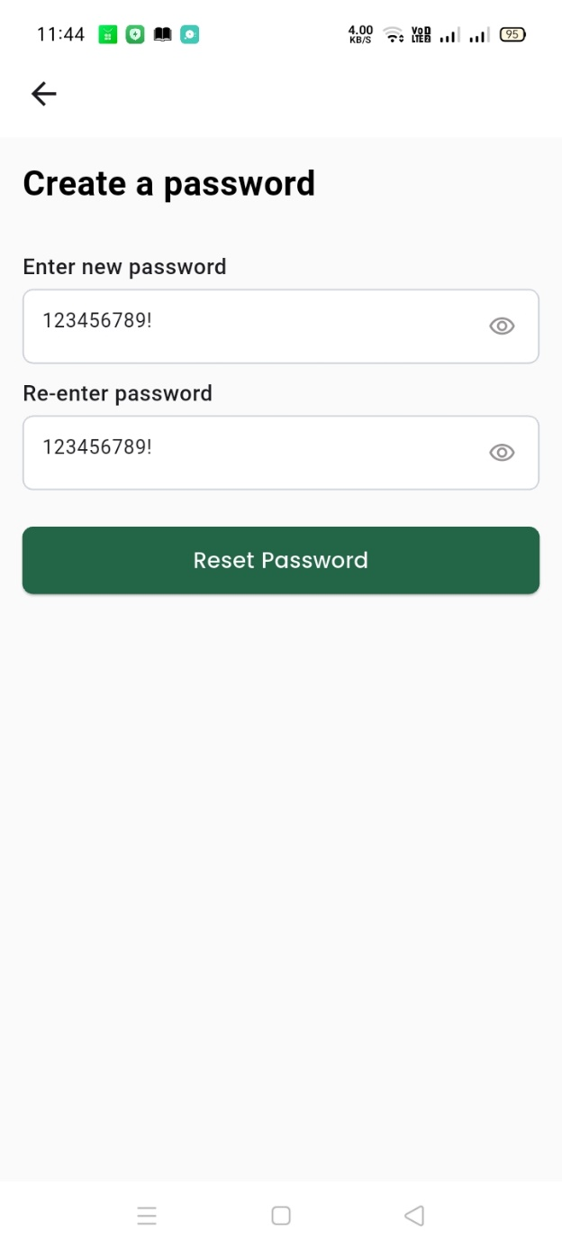

- I submitted this form and it just reloads, but it does not do anything. It does not take me anywhere. (Tested-Not reloaded now)
- I then used back button to get white screen. (Tested)

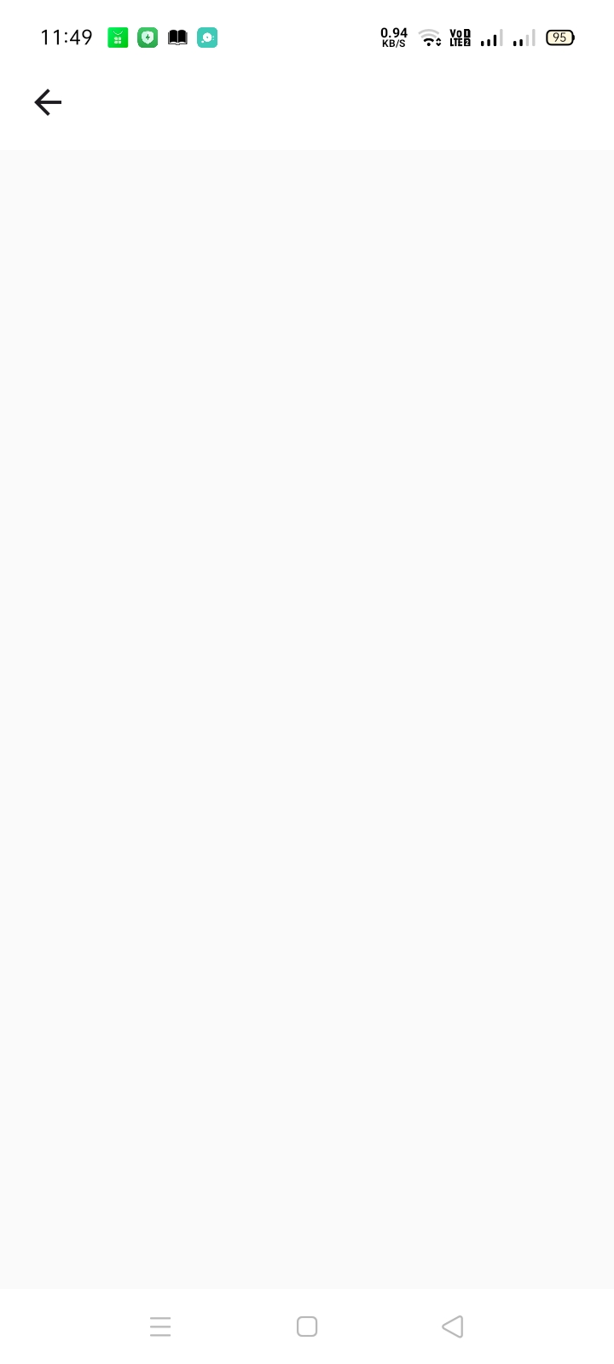

- I then went outside and then manually went to login page. Then I used the login info and I was able to login. I did not verify phone. I did not get that step. So I should not be able to login. When I tried to login using the same info on web, then I was asked to enter OTP from phone. (Face an error. I already use verification with phone when signup but when try to login it said again to verify with phone)
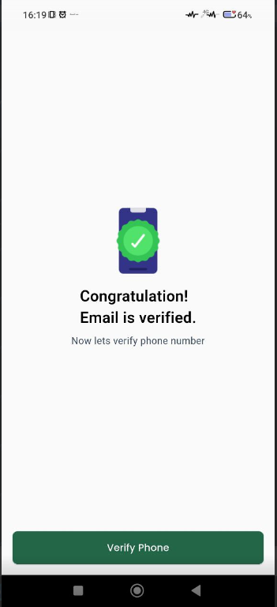
- RegisteredThen should said login successful or something. It shows “OTP Verified Successfully”.

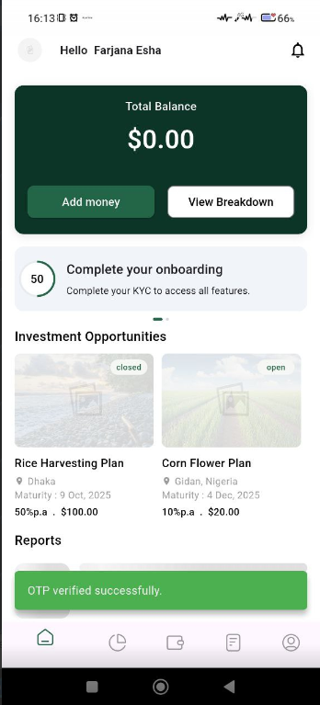
e) I just create this account but when I want to login, it said credential error. When I use forget password, then credential is working.
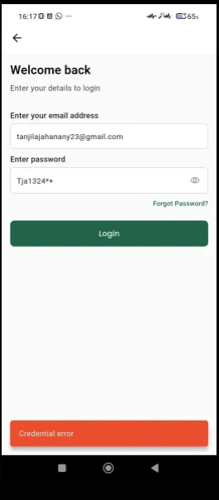

- Need to implement admin approval for investor account. An investor should not be able to access the account until approved by admin. (I cannot find approved option)
On the other handI entered identity but it shows pending. Super admin accept option missing.

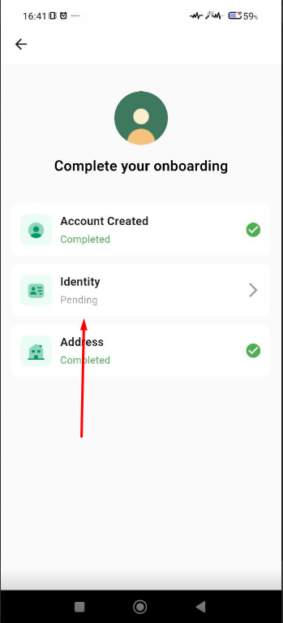

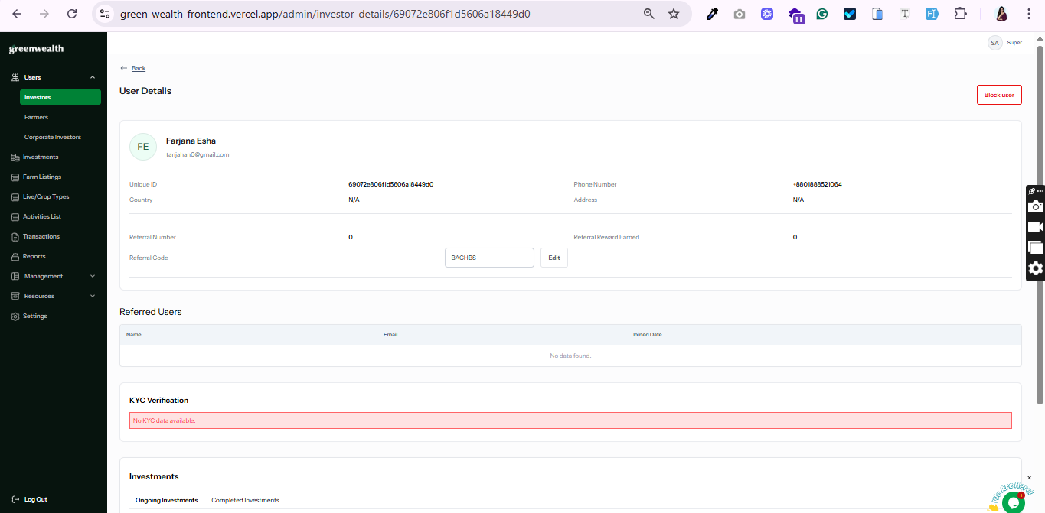

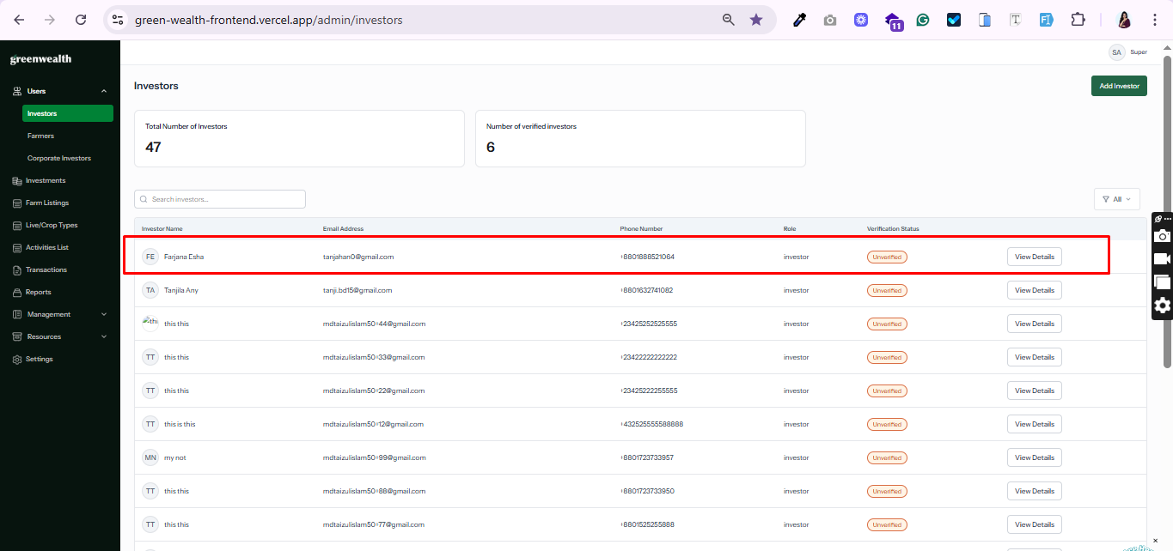

- Bank transfer: bank account seems static. We have dynamic bank info uploaded from admin/settings/bank info tab. (My account are new. But it seems already add bank account)
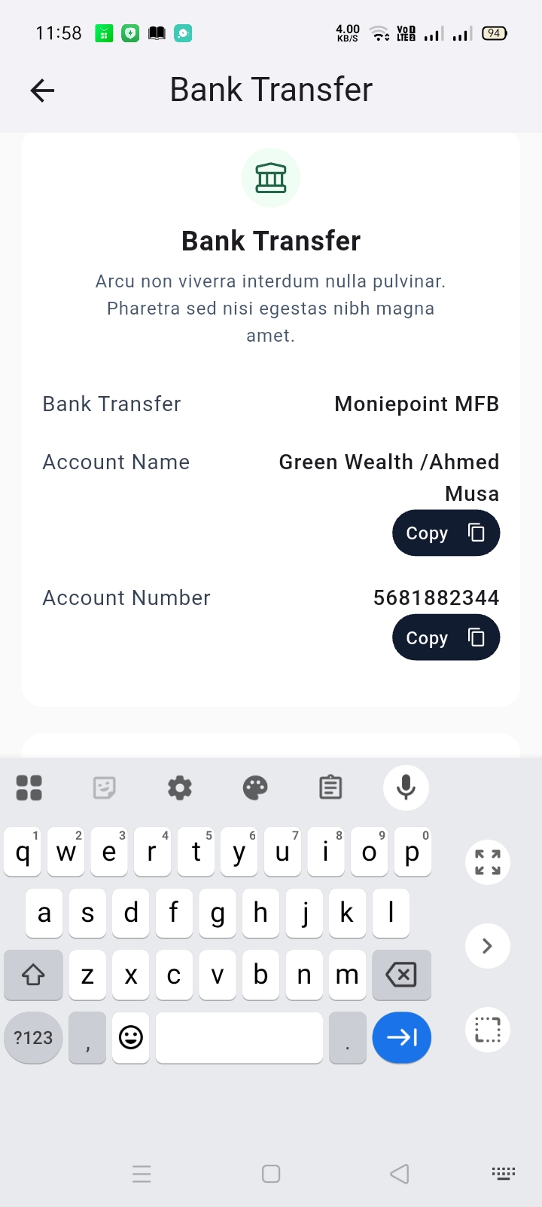

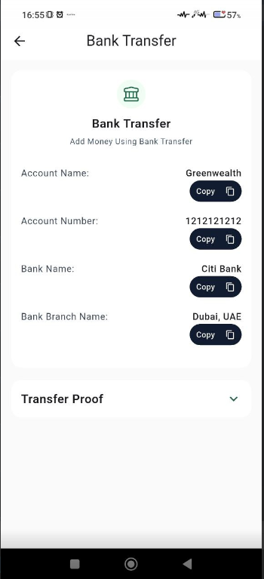

- Home screen: KYC or security PIN section should be linked to the respective section. So that user can tap on it to go to the respective location to do KYC or PIN. (Tested)
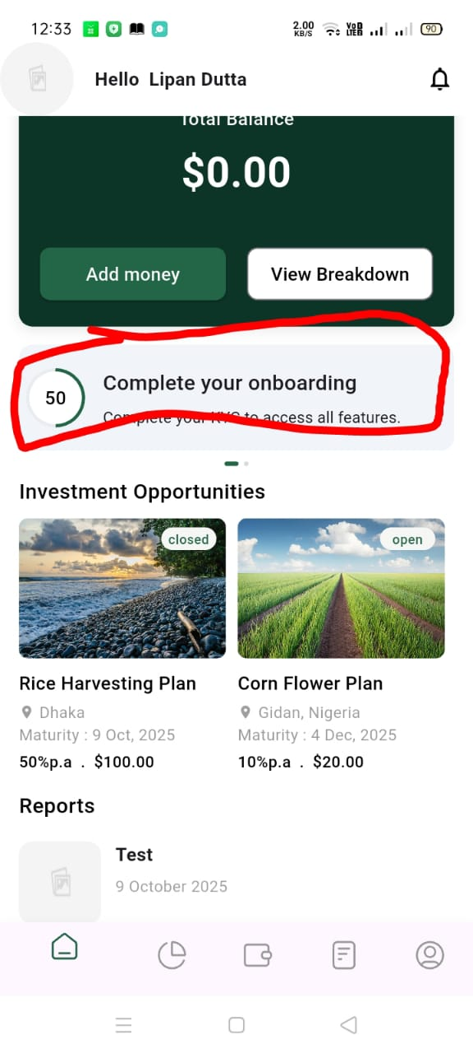

- We need similar link on menu/profile as well. (When I want to add pin, it shows phone verification & when static pin entry, it shows invalid)
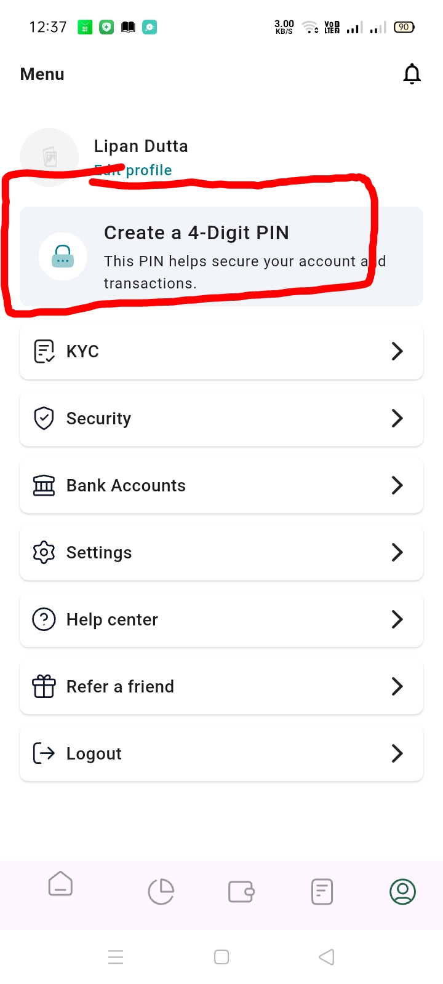
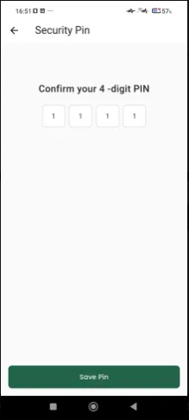

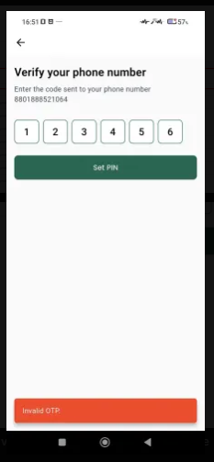

- KYC:
  - Address upload option is missing. This should be the third option. (Tested)
  - Next button does not work properly. (This button are missing now)
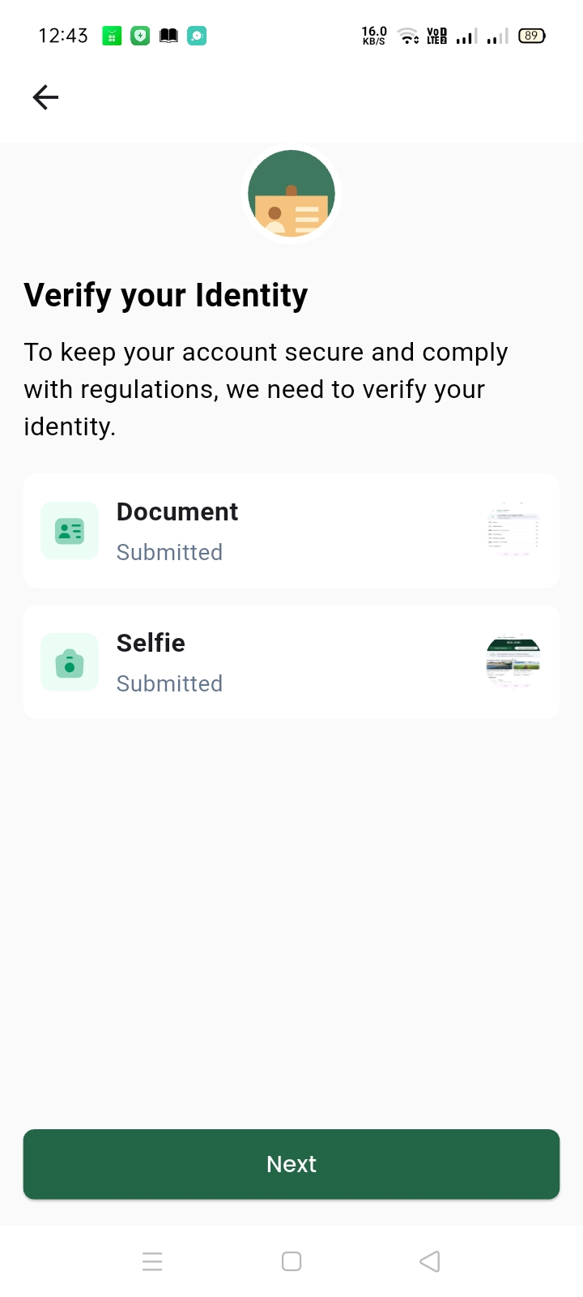

- Security PIN setting not working. I have entered PIN, then I was asked to enter PIN again. I did that and submitted. Then it did nothing. Also I am supposed to enter correct OTP to complete this process, but I did not get any option to enter OTP. (Not Done)
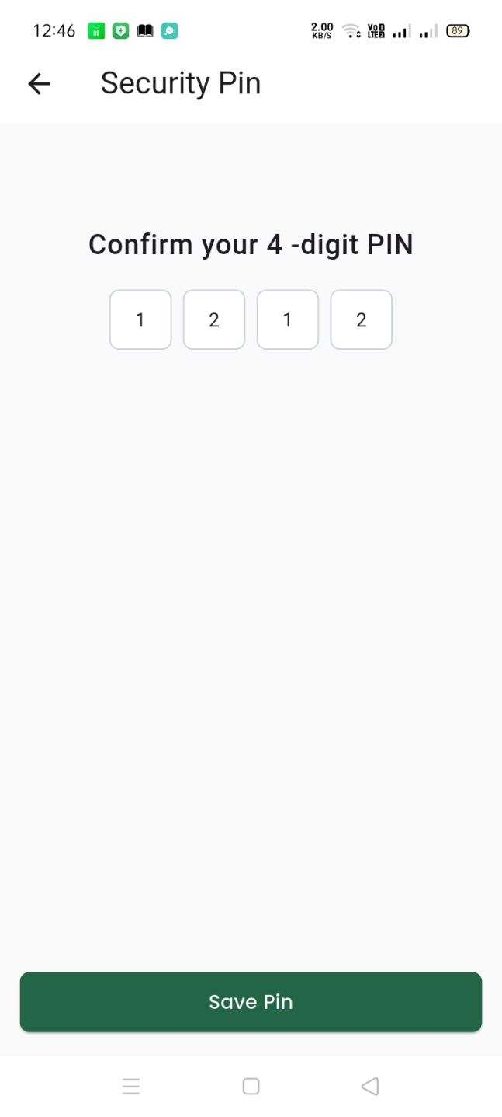

  - I tried again and then it provided option to enter OTP. But if I enter incorrect OTP, then it does not show any error. We need to review this process again. It does not work properly. Not smooth.

- Multi factor authentication seems not implemented yet.
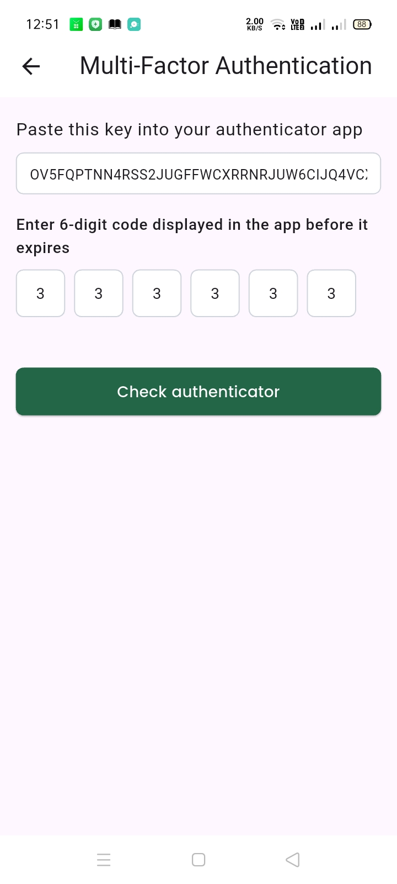

- Add Bank Account: it asks for security PIN. If incorrect PIN entered, then it does not show any error and does not do anything. It just reloads and then stays there. We need to show error message if PIN is incorrect.
- Support: need to reset the form if submitted successfully. Currently it stays. (Tested but next time user visits this page can see old information.)
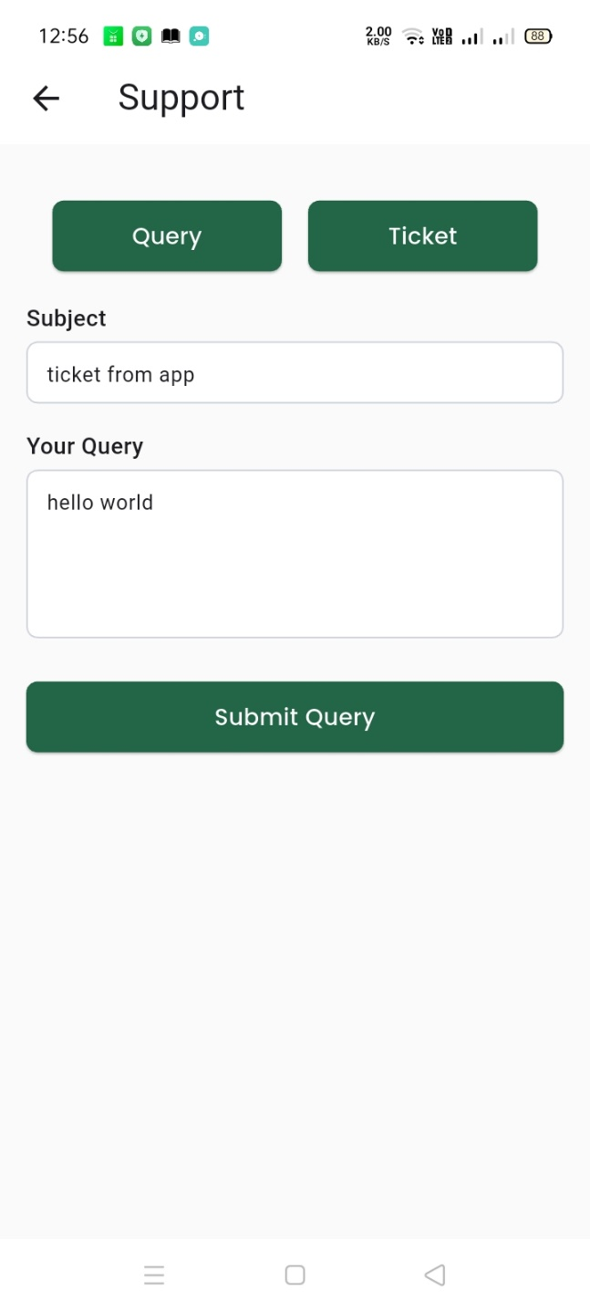

- Completed KYC verification, but it still shows message on the app. Also this 50% seems static.
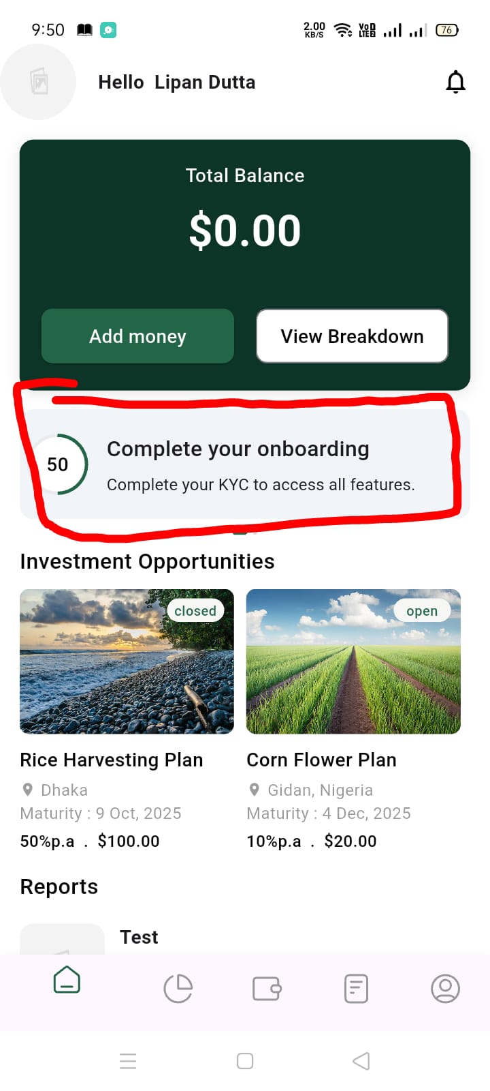

- Tried to add fund through STRIPE. I entered card information, submitted the form and then it showed me login screen within app.
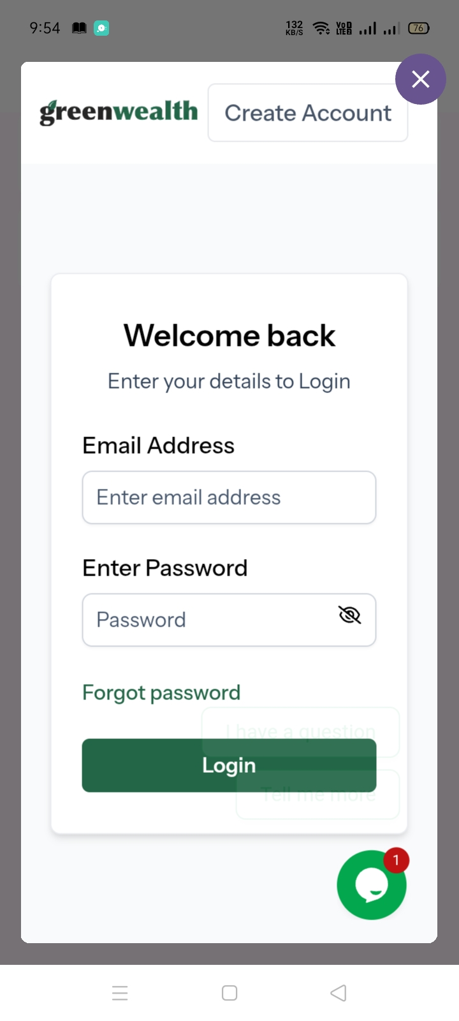

- Top up: tried to add fund through bank transfer. The success message shows in RED. It should show in GREEN.
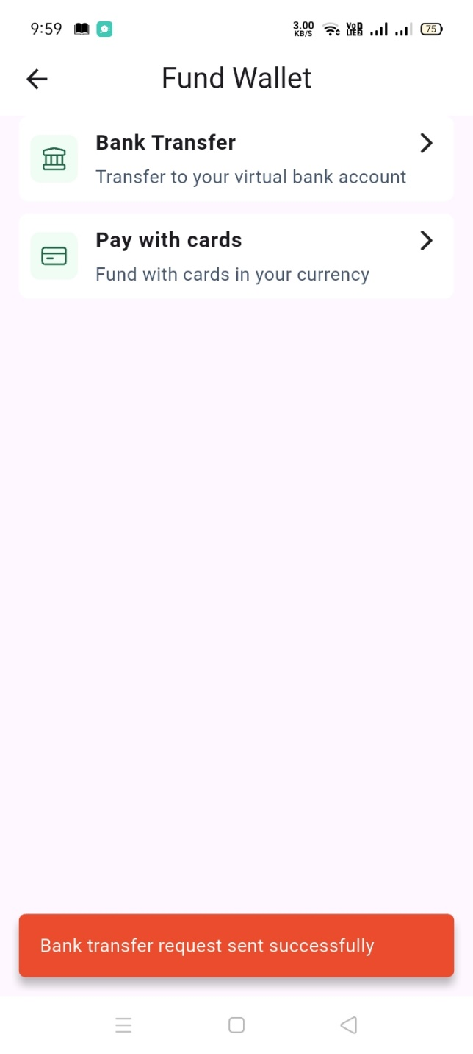

- Home/reload not working properly. I have approved transaction (top up bank transfer) from admin panel. So the money should appear in user account immediately without even reloading the screen. But I tried reload option and also visited different pages. But still it did not show up. I had to logout and login again to see the fund.
- I have submitted KYC content and admin approved it. In admin it shows verified. But in the app it shows “Submitted”. Also I tried to invest. First time I tried to purchase 50 slots, it said success but in RED color. Second time I tried to purchase 20 slots, then it said KYC not verified.
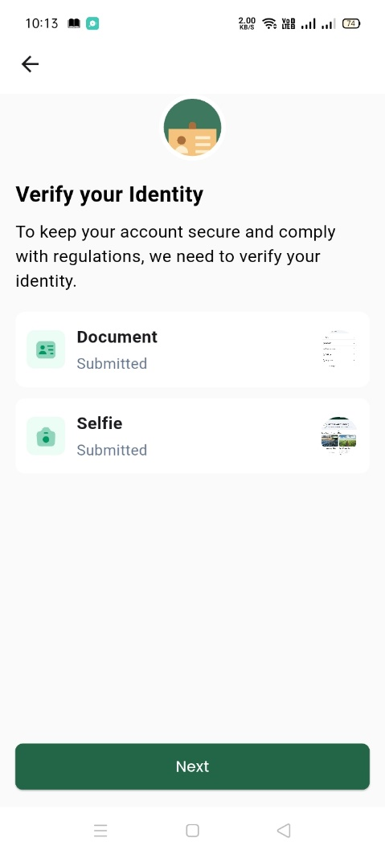

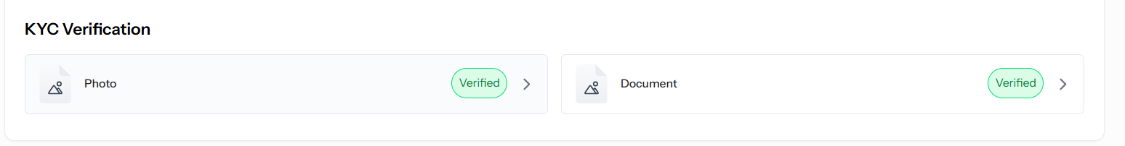

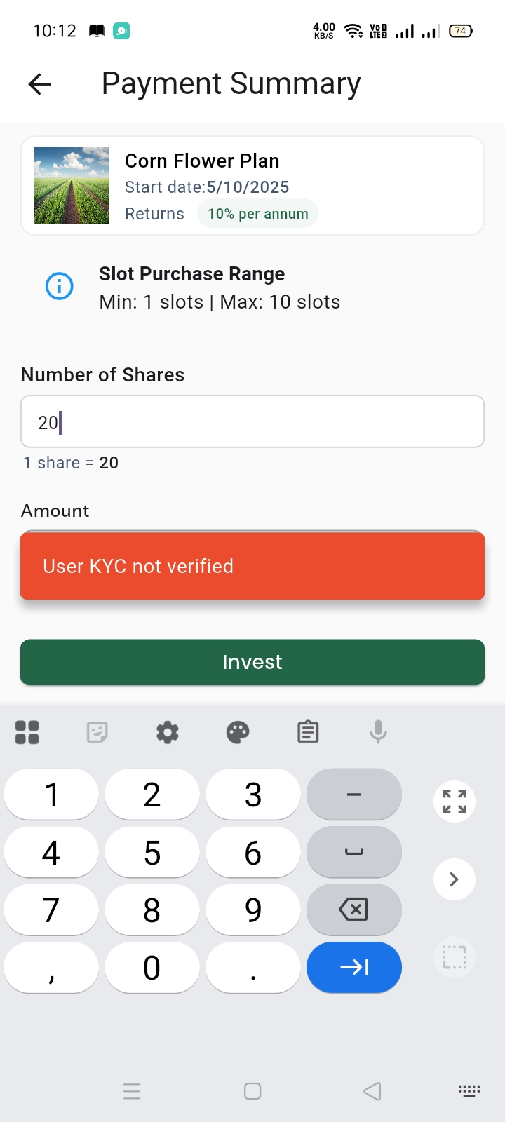

Note: we need to verify max allowed slots when someone wants to Invest.

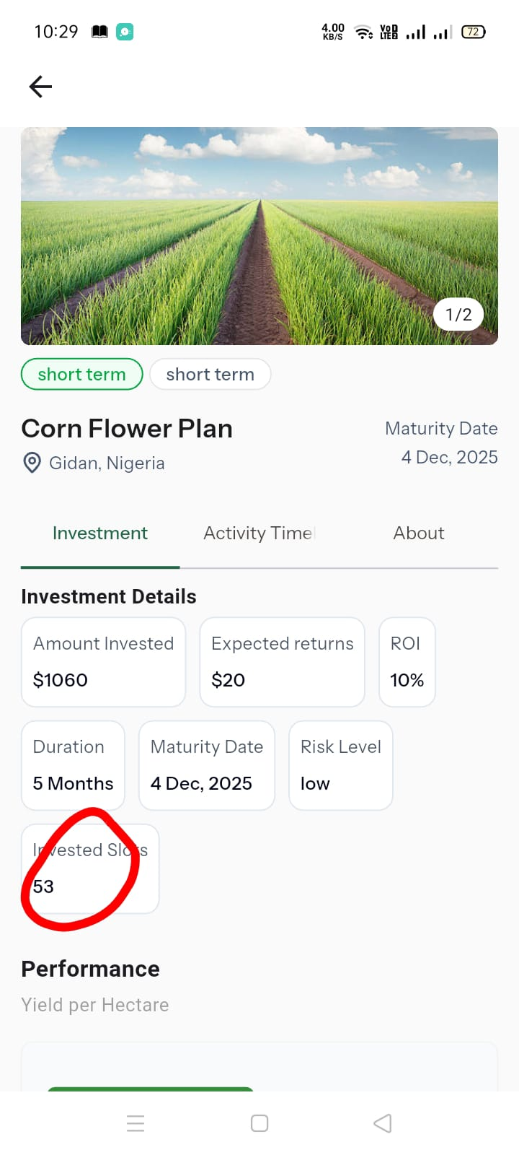

- Currently weather and soil data shows as a list. Instead we need to have an arrow to see data of previous day and next day.
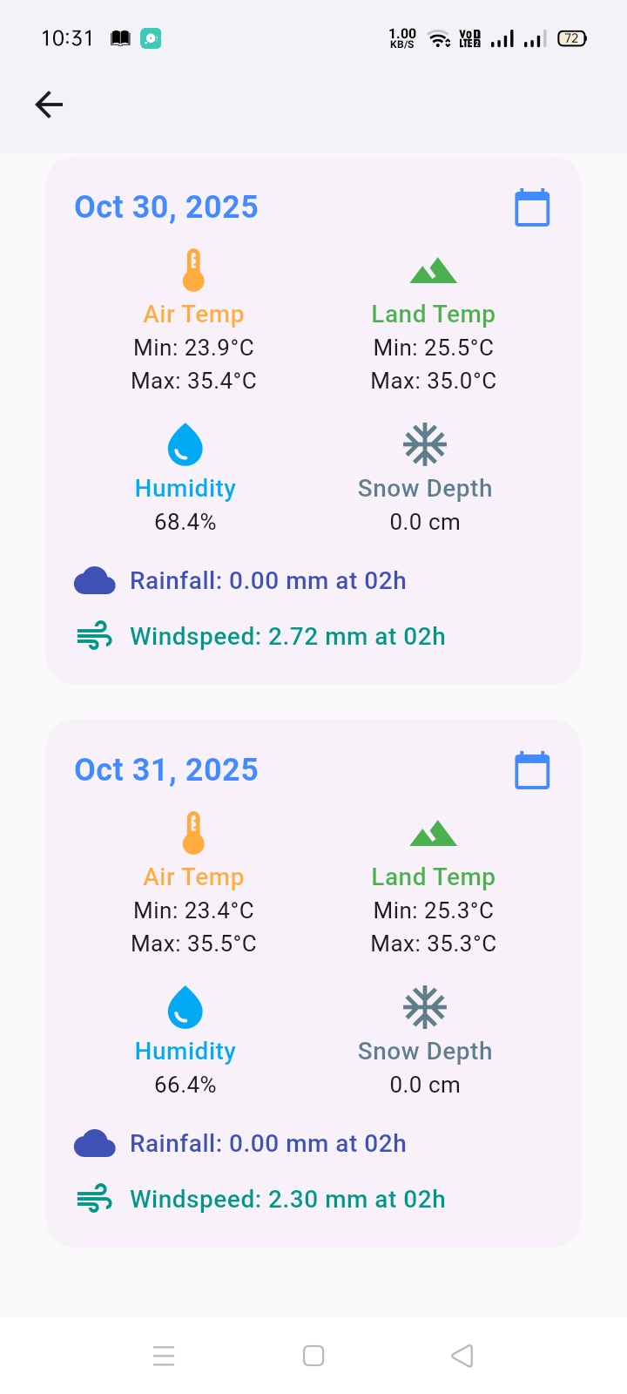

- I could not test activities in investment detail page.
- Slot price is $20. It shows I have invested 53 times. So the amount $1060 is correct. But in portfolio section it shows $1000.
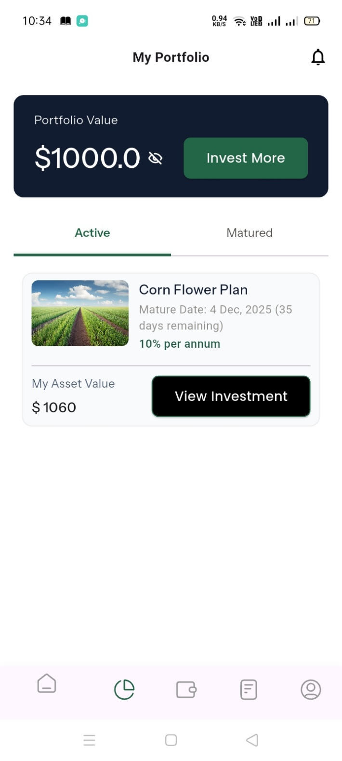

- Refer a friend: lets hide the texts from here. Also please show the referral code here with option to copy the code. (Tested)
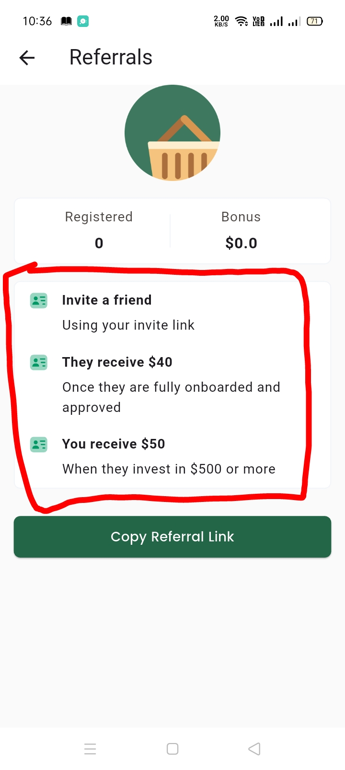

- I have requested for fund withdraw and also approved from admin panel. But I do not see that in the app. It still shows the old amount and transaction history section also does not show that info.
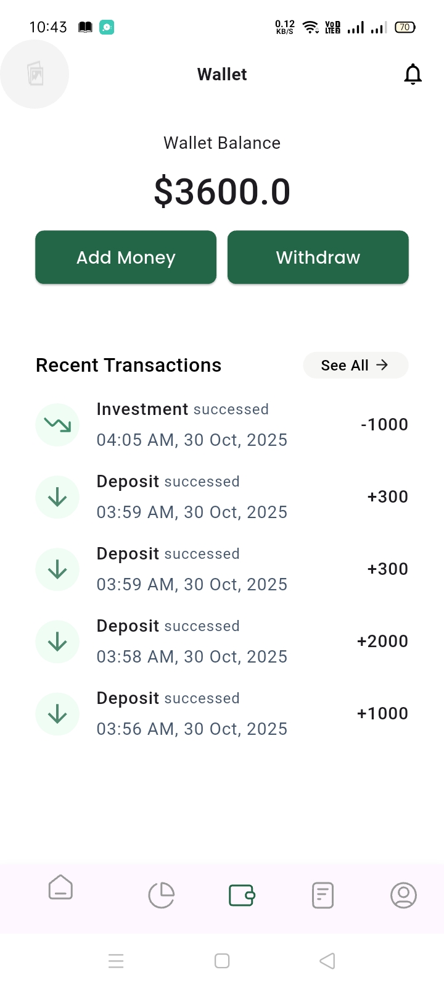

- Push notification not implemented. (Not Done)
- Edit profile page is broken. (Shows Error Massage)
